**DAILY ONLINE ACTIVITIES SUMMARY**

|  |  |  |  |  |  |  |  |
| --- | --- | --- | --- | --- | --- | --- | --- |
| **Date:** | 06/06/2020 | | | | **Name:** | AMBIKA V | |
| **Sem & Sec** | 4th Sem Section'A' | | | | **USN:** | 4AL18CS005 | |
| **Online Test Summary** | | | | | | | |
| **Subject** | | Data communication | | | | | |
| **Max. Marks** | | **30** | | **Score** | | **27** | |
| **Certification Course Summary** | | | | | | | |
| **Course** | JAVA PROGRAMMING | | | | | | |
| **Certificate Provider** | | | greatlearning academy | **Duration** | | | 3.5 hrs |
| **Coding Challenges** | | | | | | | |
| **Problem statement 1:**Write a program in C to rotate an array by N positions.  **Problem statement 2:** Given an array A of size N containing 0s, 1s, and 2s; you need to sort the array in ascending order. | | | | | | | |
| **Status:** completed | | | | | | | |
| **Uploaded the report in Github** | | | | yes | | | |
| **If yes Repository name** | | | | https://github.com/ambika0202/lockdown-coding- | | | |
| **Uploaded the report in slack** | | | | yes | | | |

**ONLINE TEST DETAILS:**  DC test was scheduled from 09:15 am to 10:00am .The portion for the IA was module 5 there were 30 questions and the time assigned was 45 minutes the questions were mcq type.

**Hu**

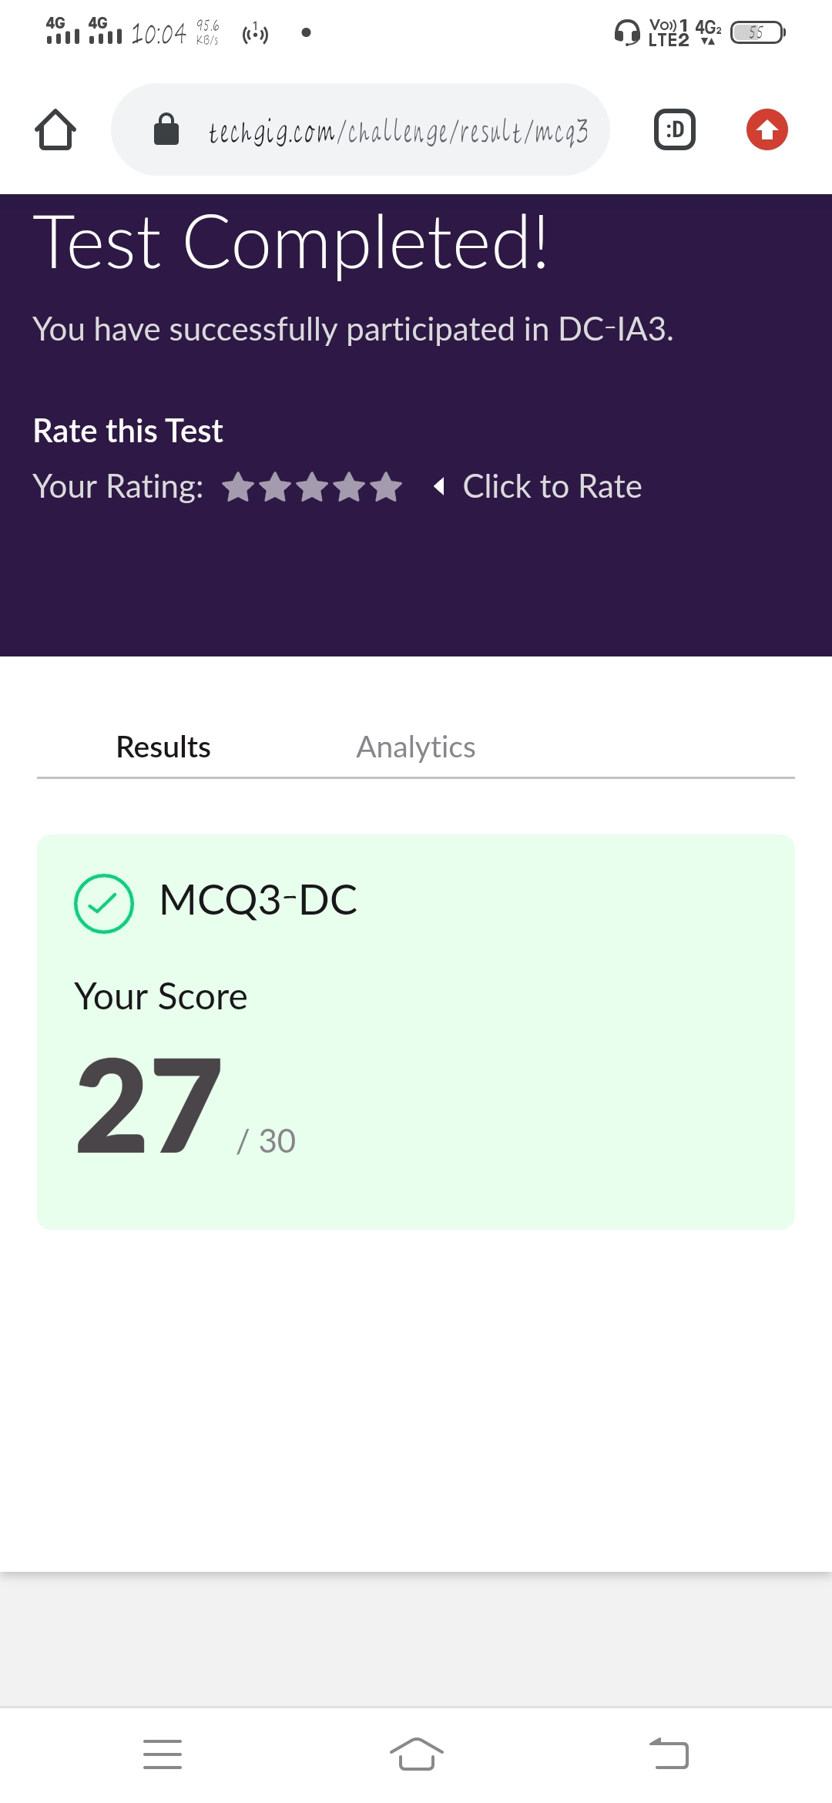

**CERTIFICATION COURSE DETAILS:**

**Name of the course**: Java Programming

**Certificate Provider**: Great Learning Academy

In this Java programming course ,today I have continued to learn new topics and this topic is about object oriented programming and inheritance in Java.

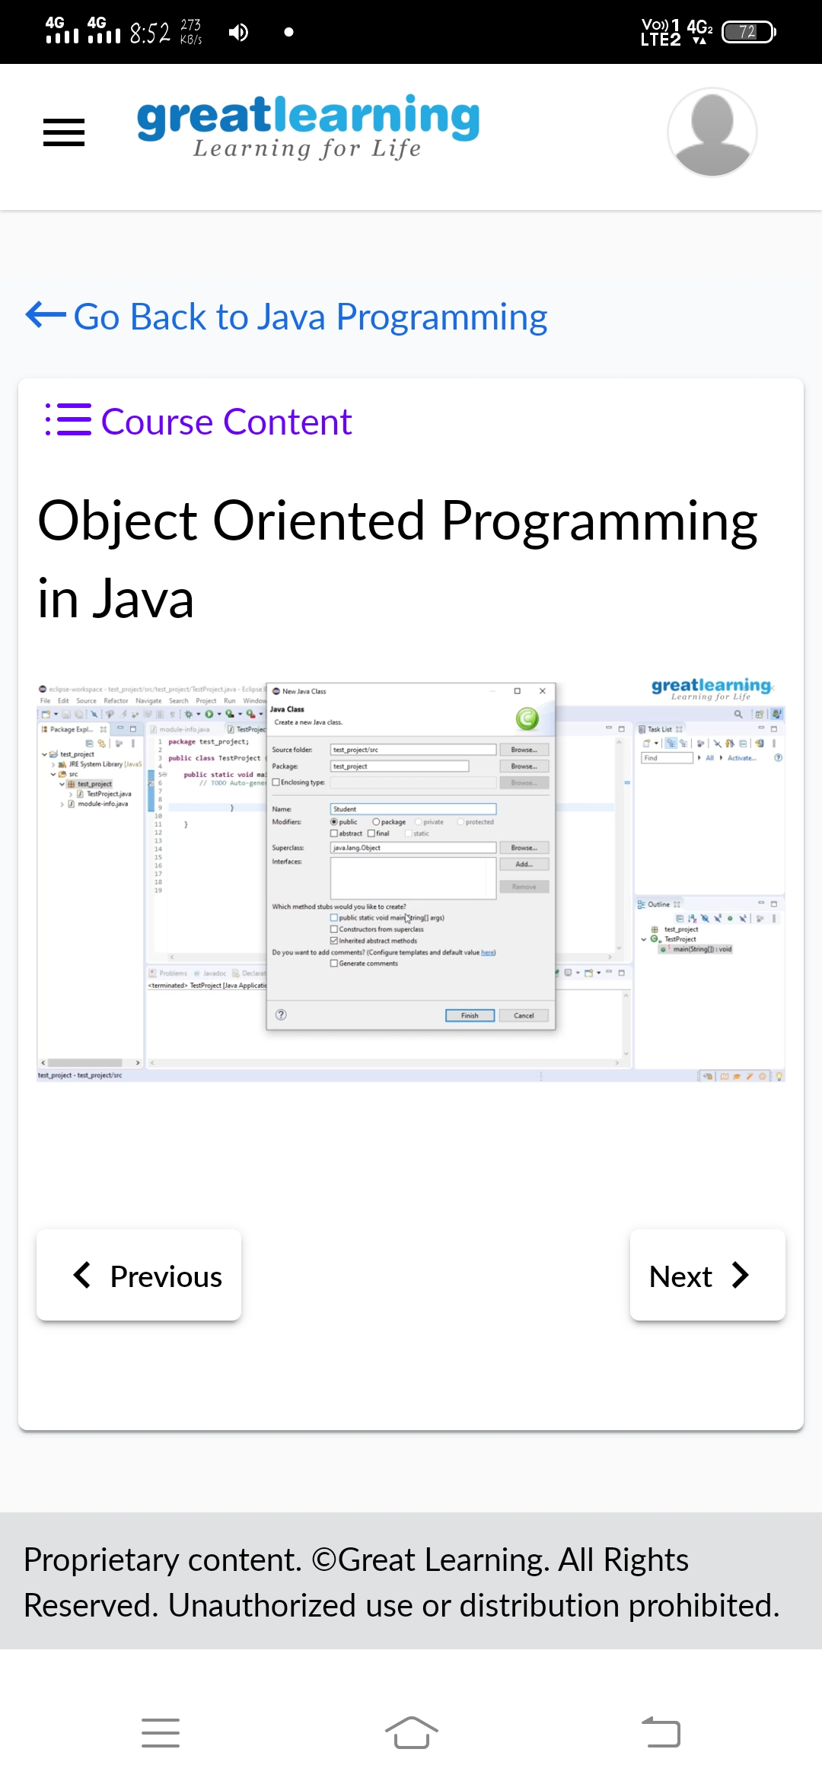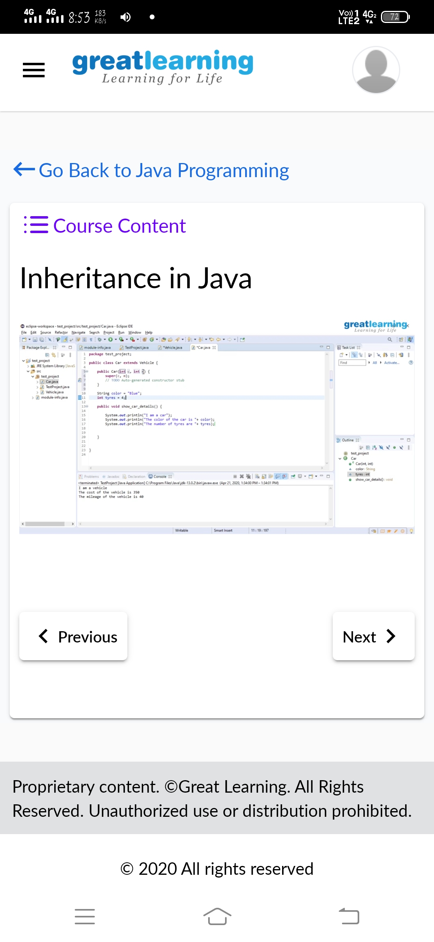

**CODING CHALLENGES DETAILS**: Every day we are given with new question of coding related to the language of java and c.

**Problem statement 1:** Write a program in C to rotate an array by N positions.

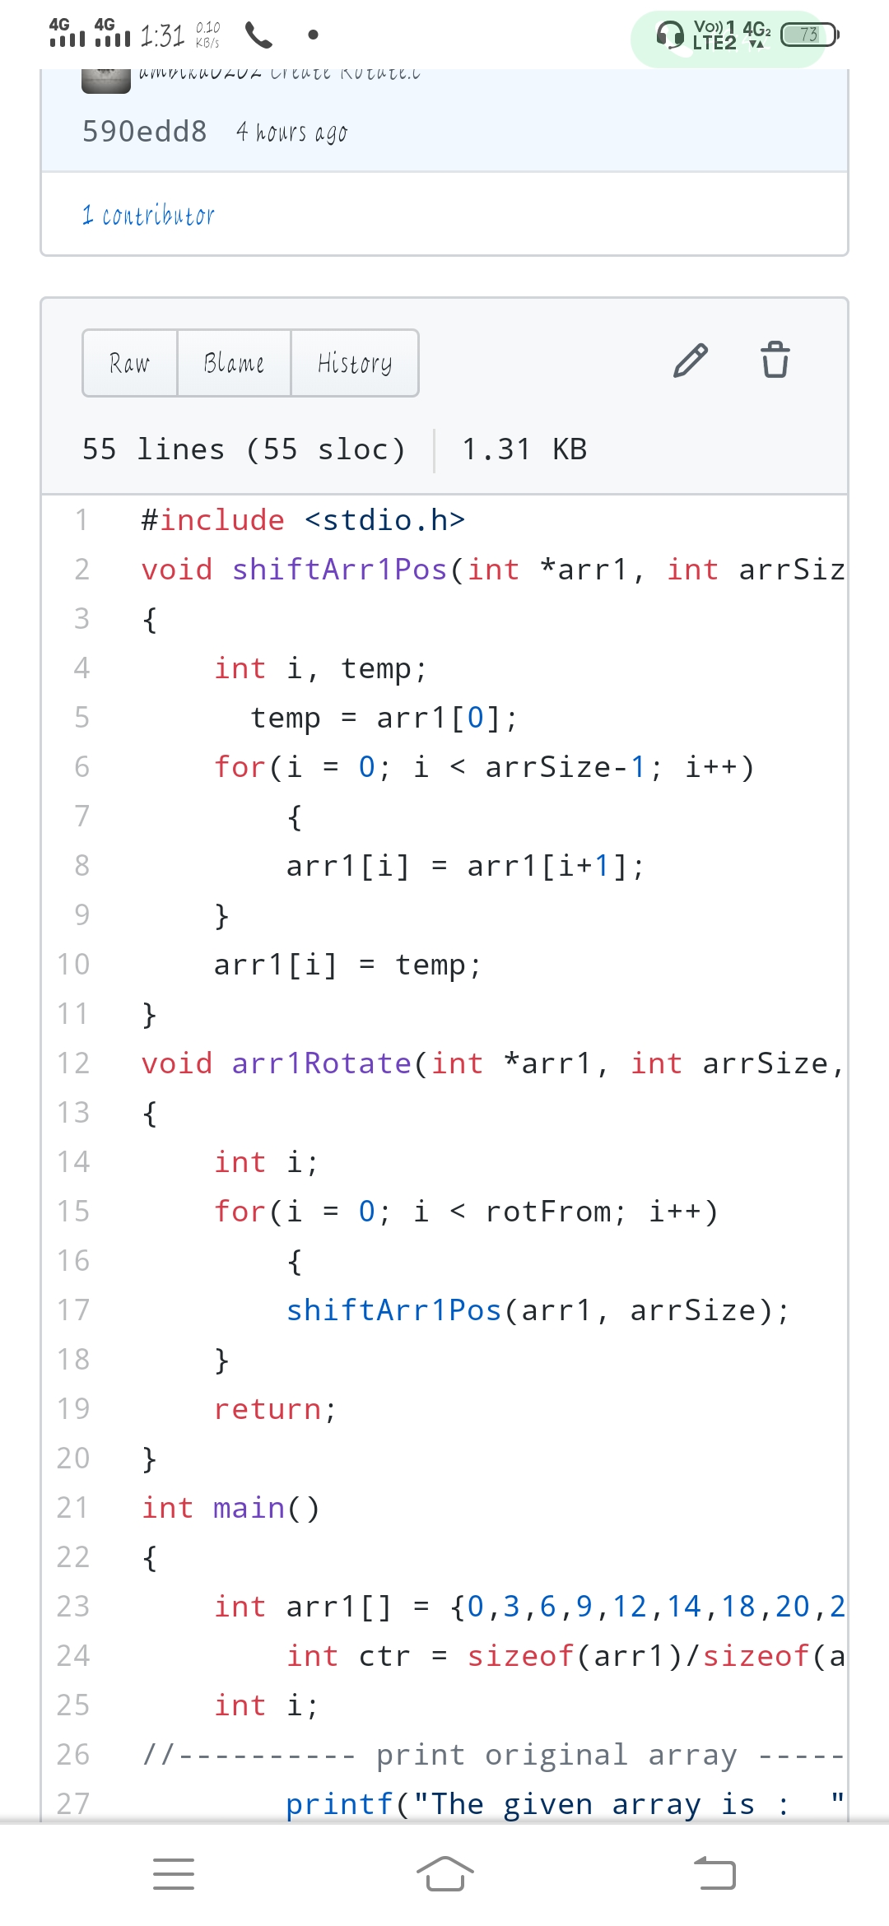

**Problem statement 2:** Given an array A of size N containing 0s, 1s, and 2s; you need to sort the array in ascending order.

